**Project Ellipse**

*What is Ellipse*? An oval shaped geometrical figure, resembling the circle, but it’s not a circle, neither is it an oval. So what is it? It has no ends, and it can take whatever shape you wish it to, just like our invention. Recycling is taking something, and using it for different purposes, a truly circular movement, but with a slight twist.

Our tasks are:

To find a simple and effective way to organize the recycling of building related, EVA, composite, polymer and food waste. To allow the people who are living on mars to save on resources and optimize their resource usage.

Aimed at the solution of this problem we developed a portable recycling station which can be used both on ship and in constructed habitat.

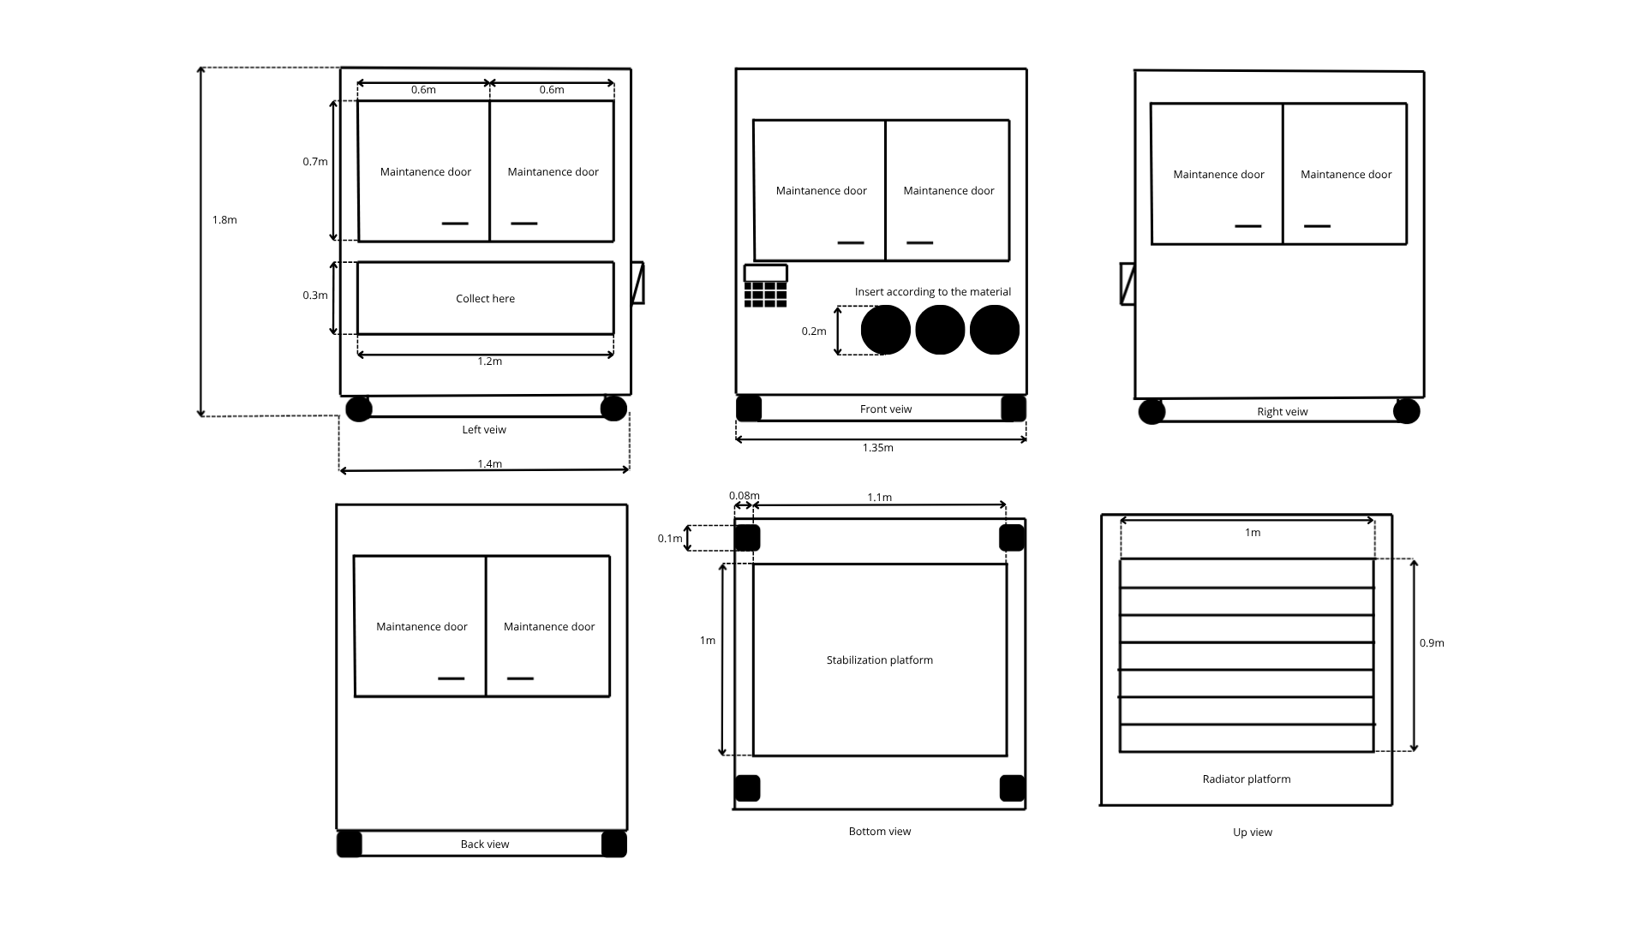

Blueprint of Project Ellipse



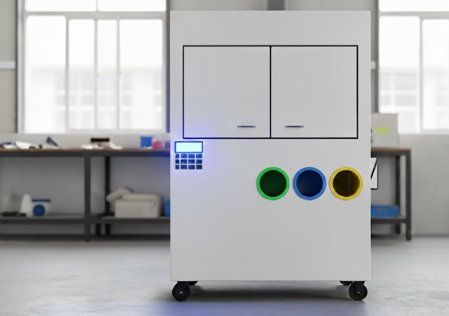

Visual representation based on the blueprint

**What are are aims?**

Project Ellipse aims to address the challenge head-on by recycling materials such as composite polymers, packaging waste, synthetic fibers, and metals like aluminium. A 3-year expedition to Mars would generate an enormous amount of waste materials which could cause harm to the environment. Ellipse is an innovation that could revolutionize life on Mars, making it sustainable and causing less damage to the environment. If the design is implemented correctly, it could reduce waste generation by up to 70%.

**Why is it important?**

One of the critical issues that NASA faces in the planning of the 3-year expedition to Mars is the waste management. On the ISS, waste is ejected into space or returned back to the Earth. Due to the enormous distance between Earth and Mars, it is not possible to send to collect waste from Mars and ejecting waste into space is also not possible as there is a leakage possibility. This highlights the importance of responsible and efficient waste management and the recycling of waste materials. That is where Ellipse comes into play. Ellipse can reduce waste and the need for materials by recycling and repurposing waste material.

**What does Project Ellipse do?**

Project Ellipse is a small recycling facility meant for Mars-based activities. It takes inorganic waste ranging from plastics to polymers, fibers, textiles, metals, and composites and recycles them into useful new forms such as ingots, plastic coils, or 3D printing filament. This way, astronauts could convert waste rather than just dumping it, making the mission more sustainable.

**How does it work?**

Waste material is sucked in through 3 intakes, one for each type of material(material should be broken down to the pieces of acceptable size).

Once inside, it has to pass through four major chambers:

Heating chamber (for melting or sterilizing the materials)

Grinding chamber (for crushing waste into smaller bits)

Shaping chamber (for remolding into useful forms)

Since every chamber interconnects with one another, materials can be subject to two or more processes if necessary.

The finished products—plastic threads for 3D printing, metal ingots, or building blocks- are released at the dispenser point (on the left side of the station).

Astronauts select the output form on the front control interface.

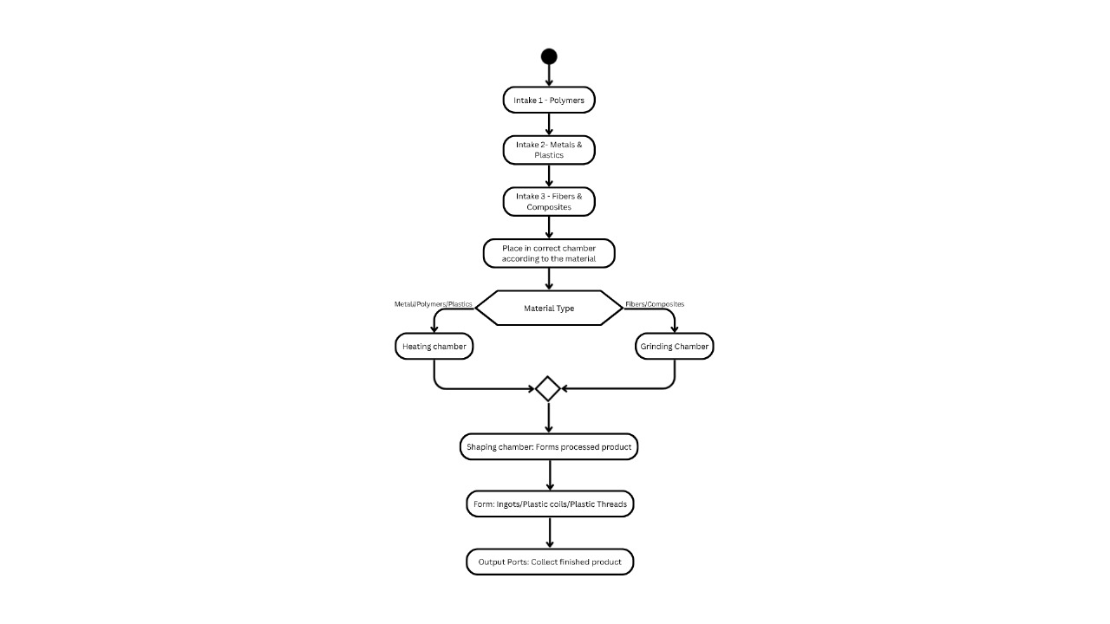

Flowchart representation of the station

**What are the benefits of usage?**

The benefits of our project include waste minimization, efficiency of natural resources, and environmental impact reduction on Mars. The project supports sustainability over the long term since astronauts will be able to convert waste into value, such as water, fertilizer, and building supplies. Long term operations in difficult and isolated environments will require continuous operation and easy maintenance through specifically designed doors, which is what is simple, reliable, and energy efficient.

**What do we want to achieve?**

We desire to achieve a fully-functioning and sustainable recycling system for Mars missions. To help our fellow pioneers to minimize waste, reuse and repurpose any item that can be reused or repurposed, helping to receive any useful materials the astronauts will need. Our focus is toward developing a sustainable, easy to operate and maintain, reliable, and energy-efficient technology which will help ensure long-term survival, reduce the need for imported Earthly resources, and set a new standard of sustainable living in space.

*Thank you for taking a look at our work! Let’s get to the stars together!*

p.s. In this project, some parts were discovered using [Chat GPT by OpenAI](https://chatgpt.com/?model=auto)